Confidential Client Adult Information
To save time, please supply the information below to the best of your ability. It is all covered by client confidentiality. However, if there is anything you do not wish to reveal at this time, please leave that space blank. When accessing this form from my website, you may print it out and bring it with you or attach it to an e-mail and send it to marklittman1@gmail.com. Please understand that sending information via email is not secure.

Name: _____________________________________________________________ Date: ______________
Address: _______________________________________ City: _________________________________
State: ____________ Zip: ________________ Email: _________________________________________
Phone: Home___________________Work_________________ Cell_____________(ok to text? Y N)
I give permission for Mark Littman to identify himself to anyone answering my home phone Yes No

Date of Birth: ________________________

Referrred by___________________________

Insurance
Insurance Company: _____________________________________________________________________
Insurance ID #: _______________________________Group #: __________________________________
Name of policy holder: _________________________________DOB of policy holder: ______________
Relationship to policy holder: ______________________________
OK to contact? Yes No

Marital Status

☐Single ☐Married ( ____ years)
☐Divorced ( ____ years) ☐Living as Married ( _____years)
☐Separated (_____ years) ☐Widowed (_____ years)

Employment Status

Are you employed? ☐Yes ☐No Employer Name: _____________________________
Occupation____________________________________
How do you feel about your job?: _______________________________

Emergency Contact Information

Name: _______________________________________ Relationship to you: ________________________
Phone: ( ) _________________

Education

☐High School Graduate? Or GED? Year___________ School name____________________

PLEASE INDICATE IF YOU HAVE ATTENDED OR GRADUATED ANY OF THE BELOW
Community College Years_________ Major__________ Grad? Y N School Name __________________

Undergraduate College Years_____________ Major___________ Grad? Y N School Name _____________

Graduate College Years_____________ Major ______________ Grad? Y N School Name_____________

Presenting Problems and Concerns

Describe the problem(s) that brought you here today: (Use back of sheet if necessary)
______________________________________________________________________________________
______________________________________________________________________________________

Please check all of the behaviors and symptoms that you consider problematic:
☐Distractibility | ☐Change in appetite | ☐Suspicion/paranoia
☐Hyperactivity | ☐Lack of Motivation | ☐Racing Thoughts
☐Impulsivity | ☐Withdrawal from people | ☐Excessive energy
☐Boredom | ☐Anxiety/worry | ☐Wide mood swings
☐Poor memory/confusion | ☐Panic Attacks | ☐Sleep problems
☐Seasonal mood changes | ☐Fear away from home | ☐Nightmares
☐Sadness/depression | ☐Social discomfort | ☐Eating problems
☐Loss of pleasure/interest | ☐Obsessive thoughts | ☐Gambling problems
☐Hopelessness | ☐Compulsive behavior | ☐Computer Addiction
☐Thoughts of death | ☐Aggression/fights | ☐Self-harm behaviors
☐Frequent arguments | ☐Problems with pornography | ☐Parenting problems
☐Crying spells | ☐Irritability/anger | ☐Sexual problems
☐Loneliness | ☐Homicidal thoughts | ☐Relationship problems
☐Low self worth | ☐Flashbacks | ☐Work/school problems
☐Guilt/shame | ☐Hearing voices | ☐Alcohol/drug use
☐Fatigue | ☐Recurring, disturbing memories | ☐Visual hallucinations
☐Other: _______________

Are your problems affecting any of the following?
☐Handling everyday tasks ☐Self Esteem ☐Relationships ☐Hygiene
☐Work/School ☐Housing ☐Legal Matters ☐Finances
☐Recreational Activities ☐Sexual Activity ☐Health

☐Yes ☐No Have you ever had thoughts, made statements, or attempted to hurt yourself? If yes, please describe: ______________________________________________________________________________

☐Yes ☐No Have you ever had thoughts, made statements, or attempted to hurt someone else? If yes, please describe: _________________________________________________________________________

Current members of household:
Name Relationship Age

Children (skip if included in household above)

Name Age Residence if not in your household

Parents and siblings (skip if included in household above)

Mother Age (if deceased, year and cause)

Father Age (if deceased, year and cause)

Stepparents Age (if deceased, year and cause)

Siblings Age (if deceased, year and cause)

☐Parents legally married or living together ☐Mother remarried: Number of times______________
☐Parents temporarily separated ☐Father remarried: Number of times______________
☐Parents divorced or permanently separated

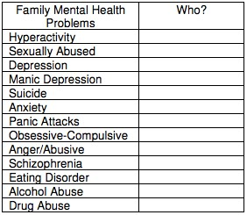

Please check if you have experienced any of the following types of trauma or loss:
☐Emotional abuse |  |  | ☐Neglect |  | ☐Lived in a foster home
☐Sexual abuse |  |  | ☐Violence in the home |  | ☐Multiple family moves
☐Physical abuse |  |  | ☐Crime victim |  | ☐Homelessness
☐Parent substance abuse |  |  | ☐Parent illness |  | ☐Loss of a loved one
☐Teen pregnancy |  |  | ☐Place a child for adoption |  | ☐Financial problems

Previous Mental Health Treatment
(use back of sheet if necessary)
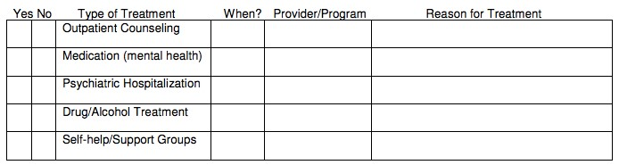

Substance Use History

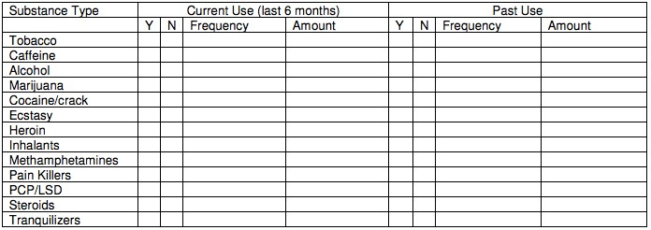
Use back of sheet for any other substances and/or over-the-
counter medications you use regularly.

☐Yes ☐No Have you had withdrawal symptoms when trying to stop using any substances? If yes, please describe: ____________________________________________________________________________
☐Yes ☐No Have you ever had problems with work, relationships, health, the law, etc, due to your substance use? If yes, please describe: __________________________________________________________

Medical Information (use back of sheet if necessary)

Current Physician: ________________________________________ Phone: _______________________

Have you ever experienced any of the following medical conditions during your lifetime?
☐Allergies ☐Asthma | ☐Headaches ☐Stomach aches
☐Chronic pain ☐Surgery | ☐Serious accident ☐Head injury
☐Dizziness/fainting ☐Meningitis | ☐Seizures ☐Vision problems
☐High fevers ☐Diabetes | ☐Hearing problems ☐Miscarriage
☐Abortion ☐Sleep disorder  ☐Sexually transmitted disease | ☐Other: __________

Current prescriptions medications: ☐None
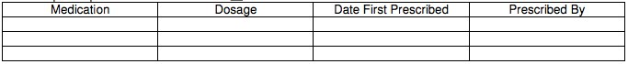
Use back of sheet if necessary.

Interpersonal/Social/Cultural Information

Please describe your social support network (check all that apply):
☐ Family ☐ Neighbors ☐ Friends ☐ Students ☐ Co-workers
☐ Support/Self help group ☐ Community Group ☐ Religions/Spiritual Center

Please describe your strengths, skills and talents, hobbies? _______________________________________

______________________________________________________________________________________

Miscellaneous Information

Military Service
☐Yes ☐No Have you been/are you currently in the military? (If no, skip this section)
Branch __________ Date of Discharge __________ Type of Discharge ___________ Rank ____________ ☐Yes ☐No Were you in combat?

Legal
☐Yes ☐No Have you ever been convicted of a misdemeanor or felony? If yes, please explain:
________________________________________________________________________________
☐Yes ☐No Are you currently involved in any divorce or child custody proceedings? If yes, please explain: __________________________________________________________________

